**Matthew Yeseta**

**Gen AI Architect**

**Here is how one must lead as a Gen AI Architect**

**End to End Project Plan Considerations for Gen Architecture Engineering**

Generative AI architect here is my End-to-End project plan approach to leading and developing a project plan for you company and executive expectations and customer needs.

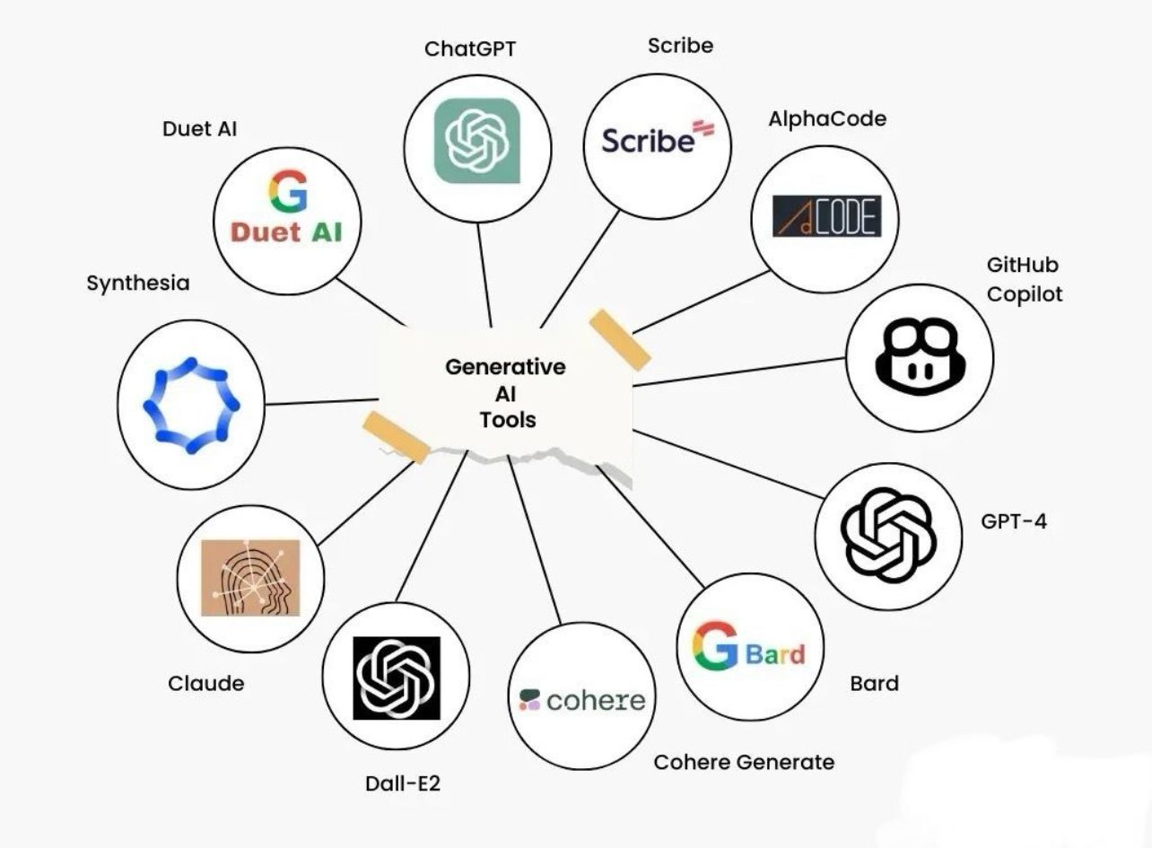

**Generative AI Project Plan: Leadership and Execution for Gen AI**

**Generative AI Strategy and Leadership Practice**

Building on experience and best practices, I propose a strategy for leading a Generative AI (Gen AI) team in navigating decisions with sponsors and stakeholders. The goal is to align Gen AI solutions with business objectives to enhance customer engagement, drive loyalty, and meet performance targets and KPIs. As a Generative AI Architect, I am responsible for managing the inherent risks of Gen AI, such as model hallucinations, and for ensuring ethical, unbiased AI that supports inclusivity. Key leadership tasks will include test case generation, fine-tuning optimization, and defect analysis to ensure model robustness and security.

**Strategic Prompt Engineering Approach**

**Objective Definition**

Define clear objectives for the AI domain in collaboration with the sponsor. Establish specific use cases such as summarization, content generation, sentiment analysis, and question-answering, aligning prompt engineering with business needs.

**Contextual Prompt Definition**

Understand the limitations of the GPT-4.x model, particularly its inability to access data beyond pre-training. Focus on leveraging internal knowledge and avoid scenarios requiring external, real-time data (for such cases, consider integrating with RAG). Tailor prompts to suit the model’s capabilities within the defined objectives.

**Iterative Prompt Design and Testing**

Adopt an iterative process for prompt development, starting with domain-specific use cases. Test and refine prompts to observe response variations based on adjustments, ultimately creating optimal prompt sets that elicit relevant, accurate responses.

**Evaluation Metrics**

Collaborate with the sponsor to define metrics evaluating prompt effectiveness, such as accuracy, relevance, and coherence. Implement A/B testing and gather user feedback to optimize prompts, refining them based on real-world performance.

**Cross-Functional Collaboration**

Coordinate across data science, product design, and domain experts to ensure prompts are both technically sound and contextually appropriate, maximizing their relevance to real-world applications.

**Generative AI Strategy for Project Execution**

**Objective Alignment**

Work with sponsors to establish core business objectives that guide Gen AI and LLM applications for specific domains and use cases.

**Requirement Analysis**

Conduct a comprehensive assessment of data availability, size, structure, and compliance requirements. Analyze resource needs, including computational and cloud storage resources, ensuring that design specifications align with regulatory standards.

**LLM Framework Development**

Select suitable LLM frameworks and pre-trained models for exploratory analysis. If custom LLMs are required, define and develop domain-specific knowledge and consider private data storage on Hugging Face or similar platforms for data uploading and model access.

**LangChain Integration**

Use LangChain to enable dynamic LLM interaction and data retrieval from external sources or custom data repositories. Leverage LangChain’s memory, prompts, and interaction loops to optimize the user experience.

**Gen AI Engineering and Execution Plan**

**Data Preparation and Curation**

Organize domain-specific data to improve model responses. Ensure training datasets include diverse, high-quality samples, creating an LLM training set that mirrors expected real-world interactions.

**Data Cleaning and Preprocessing**

Prepare data by removing bias and ensuring a professional tone. This process may involve tokenization, vectorization, and semantic analysis to align data formats with the LLM requirements.

**Data Augmentation**

Enhance the dataset with connections to multiple real-time data sources for question-answer data, using LangChain for integration. This supports dynamic prompt interactions and real-time data testing.

Prompt Engineering and Fine-Tuning

Develop various prompt templates (e.g., zero-shot, few-shot, chain-of-thought) that meet business objectives. Implement LangChain to orchestrate templates effectively, ensuring optimized chat and response quality.

Iterative Fine-Tuning

Engage in continuous prompt refinement, adjusting prompts based on real-world interactions and feedback. Use techniques such as reward modeling, PEFT, and LoRA to improve LLM outputs, driven by business success metrics.

**Gen AI Cross-Functional Collaboration**

**AI Engineers & Data Scientists**

Lead AI engineers in fine-tuning LLMs, developing APIs, and integrating LangChain pipelines. Ensure the team is well-versed in preprocessing, data curation, and model validation, focusing on seamless deployment and infrastructure scaling.

**Business and Product Owners**

Align AI development with business goals by defining success metrics and ensuring that LLM solutions meet user requirements and achieve desired outcomes.

**Technical Leadership and Knowledge Transfer**

As a senior leader, fostering an environment of continuous learning is essential. Organize knowledge-sharing sessions to stay updated on advancements in transformers, fine-tuning techniques, and LangChain, driving strategic business goals to enhance customer engagement and loyalty. This approach ensures that the team remains at the forefront of LLM technology while achieving tangible business impacts.